EXPERIMENT 8
Name: Padma Priya D Roll No: 240701377
AIM
To design a storyboard representing the user interaction and flow of an application using low-fidelity wireframes.
OBJECTIVE
- To understand user behavior and interaction
- To visualize real-life usage of an application
- To create low-fidelity storyboard using wireframes
TOOLS USED
- Balsamiq (Wireframing Tool)
THEORY
A storyboard is a visual representation of how a user interacts with an application in a real-life scenario. It shows the sequence of actions, screens, and user responses.
In this experiment, a low-fidelity storyboard is created using Balsamiq, where multiple screens are arranged in a single layout to represent the application flow.
PROCEDURE
- Opened Balsamiq and created a new project
- Added multiple mobile frames in a single screen
- Designed storyboard based on a real-life scenario
- Used basic shapes, text, and icons to represent user actions
- Created the following screens:
  - Notification / Initial screen
  - Splash screen
  - Dashboard screen
  - Profile screen
- Added short descriptions to explain user thoughts and actions
- Maintained low-fidelity (sketch-style) design
STORYBOARD DESCRIPTION
The storyboard represents a real-life scenario of a student using the StudyMate app:
🟦 Screen 1 – Notification Scene
- User is free and planning to play a game
- Suddenly receives a notification from the app
- Indicates new assignment alert
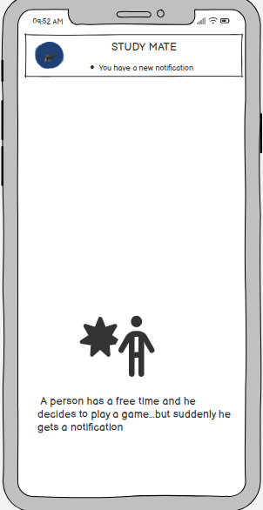

🟩 Screen 2 – Splash Screen
- Displays StudyMate app interface
- Shows tagline and app purpose
- User understands that app helps track deadlines
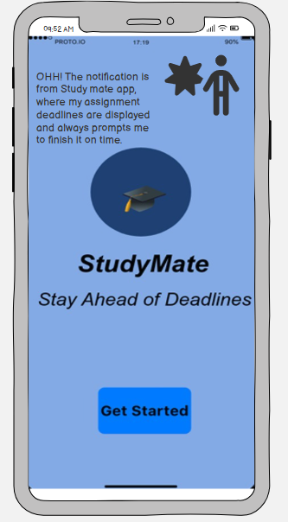
🟨 Screen 3 – Dashboard Screen
- Shows list of assignments
- One assignment is pending
- User realizes urgency and decides to complete work
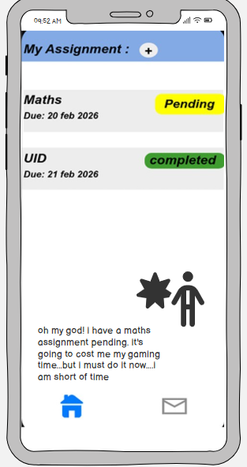

🟥 Screen 4 – Profile / Completion Screen
- Shows user details
- Indicates all assignments completed
- User feels relieved and free from deadlines
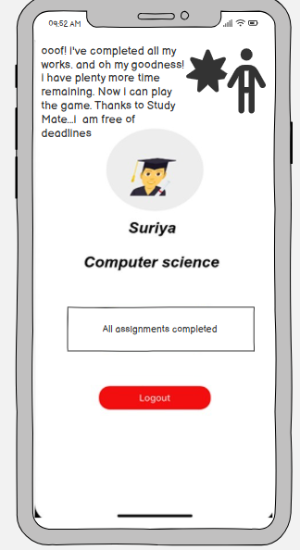

USER FLOW
Notification → Open App → View Assignments → Complete Tasks → Profile → Logout
RESULT
Thus, the storyboard representing the real-life user interaction and flow of the StudyMate application was successfully created using Balsamiq.
LINK
https://balsamiq.cloud/schwmlk/pppfkbe/rA310

